MultiTrace

Import text files
Import binary files
The basic module, Introduction into using MultiTrace, first steps
Menu File (Store settings, Image, Print)
Menu View (Height, Grid, Style, Help lines)
x-Zoom (Moving cursors and borders)
y-Zoom
Baseline trekking (zero offset correction)
Process data (Multiply, Add,…Polynomial,, Insert, Expand…Clock drift, Sections,…Integrate)
Processing two channels (add, subtract, abs)
Menu Filter (Smooth, Peak elimination, Run. mean)
Menu Calculations (Count events, Statistic, Synchronize, Histogram, PlotChCh, Frequencies)
Analyse Dives
Analysis of dive bouts

What is MultiTrace and how do I start it?

MultiTrace is a Windows programme to allow you to present and analyze up to a maximum of three channels of 16 bit data. To start, click at the entry "MT...EXE" of the Windows Explorer.

The Main Dialog

After starting MultiTrace you get the Main Dialog.

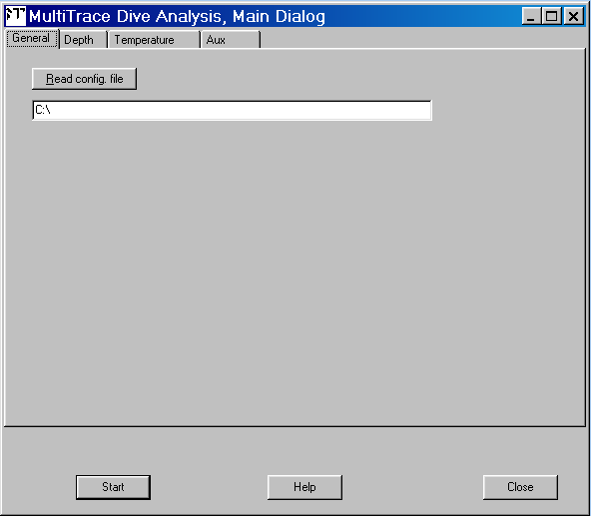

Fig 1 Main dialog, setup file

At the TAB-sheet “General” there is the possibility to load the settings of a former MT-session. At 'Read Config file' enter the name of the file that contains the settings of a former session. These are the file names, the sampling rates, start times,... but also the parameters for the analysis of the dive events. If a 'config file' already exists, then type in the name of this file in order to re-install these settings.

Note: It is not necessary to fill in the config-file field. MT works just as well. This field is only to load settings stored at a former MT session. At the very first session this file of course does not exist, so let it empty when you launch MT the first time.

Note also that MT automatically stores and reloads all settings of the preceding MT session. This option here is to load settings of a specific session maybe some weeks or month ago. You can store your settings at a later step (menu “File/Safe settings”)

Using ‘Read config file’ you can enter the configurational data which define the way the programme is set up. MultiTrace takes into account all settings that you type in this menu and other places. The next time you start MultiTrace these options will be automatically used. You can, however, record any number of set up configurations. For example, if you have 12 groups of related data, each group consisting of one file with dive depth, another with jaw activity and another with temperature and each group has a configuration file consisting of the start times and dates of each file as well as the intervals at which the recordings were made etc. Should you wish, at any time later, to analyse a particular data group, you will only have to give in the configuration file name for all the relevant information whereupon all pertinent data are recalled.

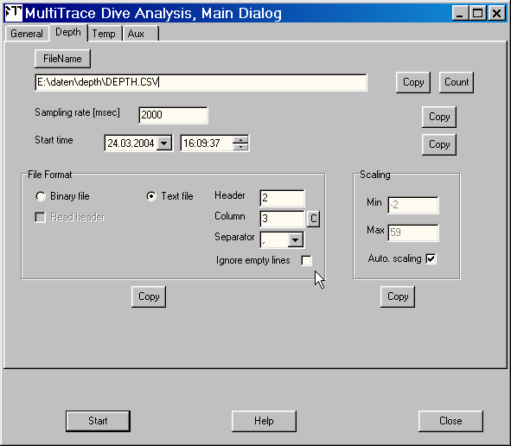

Fig 2 Main dialog

Use the other three TAB-sheets to fill in the names and various specifics of the files that contain the recorded data. Press the button ‘FileName’ to select the data file. Fill in the sampling rate and the start time. In the box ‘File Format’ select either ‘Binary’ or ‘Text File’. The data file is of kind ‘Text’ if you can open the file by programs such as Word or Excel and if you then can read the numbers that the file contains. If you are not sure what kind your file is contact Jensen Software.

The Count-Button changes the extension of the filenames to .000, .001, .002,… and so on. This is useful in case you stored the channels as binary files (see below “Export of the channel data into a binary file”).

At the TAB-sheet ‘Depth’ enter the parameters of the file that contain the depth (pressure) data.

Additionally you may import two other channels e.g. speed or temperature in the same way as the depth data file. Note that MULTITRACE analyzes only channel 1 (depth). Of course it is not necessary to load three channels. Do not enter a filename at tabsheet 2 and tabsheet 3 if you don't want to import these channels.

Only the page for the 1st channel contains 'Copy'-buttons. Use these buttons to copy the settings to the other pages. The copy-button below the box ‘Scaling’ is special: At a left mouse click only the ‘Auto Scaling’ checkbox will be copied, at a right mouse click also the content of the ‘Min’ and ‘Max’ fields will be copied.

How to import Text-files

Actually MULTITRACE is designed to import and to process data files containing binary data. However, it is possible to import also text files. Restrictions: The files must contain pure ASCII code (i.e. no WordPerfect or something else format) and the data must be ordered in columns. One of these columns can be imported per channel. The decimal point of the numbers may be also a comma.
In the “File format” box set the column number, the number of header lines and the data separator.

Column : Type in the number of the column of the relevant data. The C-Button automatically counts up the column nr for the other channels.

Header : If the data file text formatted contains some general information at the top of the file then fill in the size of this header (=number of lines). MULTITRACE will then overread this header and will jump directly to the first line (line: header+1) that contains data.

Separator: The data of each line of the data file may be separated either by a comma, by a semicolon, by the tabulator character or only by spaces. Select the apt character of the list or type in the separator character.

Ignore empty lines Some data file contains lines where the corresponding column carries no value e.g “20/12/07 12:45:50, 3.52,,77.00” At this line there are values for the first and the 3rd channel but not for the 2nd channel. “Ignore empty lines” controls how to cope with such lines. If “Ignore” is enabled then MT passes such a line and jumps to the next line. Else MT interprets such a line as if the 2nd channel carries a constant value. Since MT does not read date and time information of the data files but only the data values it is important that the data are continuous i.e. all values are of the same time difference. Example

06/01/2007,21:01:02,125
06/01/2007,21:01:04,127
06/01/2007,21:01:06,
06/01/2007,21:01:08,
06/01/2007,21:01:10,122
06/01/2007,21:01:12,126
06/01/2007,21:01:14,119
:
At the above example there is constant time difference of 2 sec, sometimes values lacks. Here do not enable “Ignore”. MT then will read also the lines with lacking column values (empty) and set it equal the smallest value of this channel.

06/01/2007,21:02:40, 00, 85
06/01/2007,21:02:42, 01,
06/01/2007,21:02:44, 03,
06/01/2007,21:02:45, ,87 (!)
06/01/2007,21:02:46, 04,
06/01/2007,21:02:48, 04,
06/01/2007,21:02:50, 05, 88
06/01/2007,21:02:52, 05,
06/01/2007,21:02:54, 05,
06/01/2007,21:02:55, ,86 (!)
06/01/2007,21:02:56, 07,
06/01/2007,21:02:58, 09,
06/01/2007,21:03:00, 09, 92
06/01/2007,21:03:02, 09

At the example above the file contains two channels. Channel 1 (col. 3) are data sampled by a samp. rate of 2 sec. Channel 2 (col. 4) is sampled by 5 sec. Here enable “Ignore empty lines” for both channels since MT should not read the lines marked by the red declamation mark in case of channel 1 and for the 2nd channel (column 4) MT should read only the lines 21:02:40, 21:02:45, 21:02:50, 21:02:55 and so on, ignoring the other lines (21:02:42, 21:02:44,…).

Example to Separator and column: Assume you want to import the data of the 4th column of this text file.
The data columns are separated by TABs.

13.09.97 12:30:45 4.56 197 12.55 -5.67 354.34
13.09.97 12:30:50 4.87 188 14.67 -6.34
13.09.97 12:30:55 4.99 187 13.29 -4.19 367.43
: : : :

Then set column to 4, header to 0 and the separator to TAB to load the data: 12.55, 14.67,13.29,.... . These are the data of the fourth column. In this example date and time together is only one column (not two) since they are separated by a single blank and not by the separator TAB.

By some word-processors the sign "TAB" is not visible. It looks as several spaces.
Assume (same example) the columns are not separated by TABs, but by several blanks. Then you have to fill in: header=0, separator=blanks and columns =5 (!) to load the same data column as in the preceding example, because the time-column in this case is the 2nd column.

Do not forget to enter the correct sampling rate at Sampling Interval [msec] and the start time, since MULTITRACE does not read date and times of the data files (Exception: A binary files created by MT contains the start time. MT reads this information if Read Header is enabled). Apart from this exception, only the settings at the main dialog - such as ‘start time’ and ‘sampling rate’ - are relevant for MT, not date and time information contained in the file. For the example above that means: In case you want to import the last column, set the sampling rate to 10 sec, not to 5 sec (as the other columns) and enable ‘Ignore empty lines’.

It may be difficult to find the apt settings of specific files, some files even must be converted before they can be used by MT. In case you need help, please contact us (info@jensen-software.com) we would be pleased to help you.

When pressing the Start button the data file text formatted will be imported by MULTITRACE and immediately converted internally into binary format.

Scaling for text files

Because of the conversion into binary format MULTITRACE must know the range of the data. Enter the correct values at the box ‘Scaling’. Example : Assume the data are in the limits of -20 to +200 then you should type in these values at ‘Scaling’. In case you are interested only in the data between +100 to +180 then you may choose these values to obtain a better resolution.

If ‘Auto scaling’ is enabled then MT searches the minimum and the maximum i.e. MT itself calibrates this channel. The scaling should cover the current data range: The parameter 'min' must be chosen so that it is smaller than the smallest data and the value 'max' must be chosen so that it is always greater than the greatest data of the data file.

Example: Assume you have selected min=0 and max=10. Your data are of the range 0 .. 10. If you later multiply your data by 10 (see below ‘Process data’) then the data ranges from 0 to 100. 100 is too large since it is greater then 10. Thus, before loading your data file, set here max=100 and disable 'Auto scaling'. Then you can multiply later your data by 10 without problems.

You may load binary and text files simultaneously. Example: Channel 1 and Channel 3 may be binary files, and Channel 2 may be a column of a text file.

Hint: Loading text files is much more time expensive than loading binary files. If the text files are large and if you have to load such a file very often, then it is recommended to convert this file into a binary file: Import it as text files, then store it as binary files. (described in Chapter “Export”)

How to import binary files

If your data file is a 16-bit binary file, you can use this option to import such a data file. However, most loggers nowadays provides the data text formatted, thus this option is less used. Exception: MT can export the data of a channel as a 16-bit binary file. Such a file is much faster loaded and it is much smaller than a text file. So, in case you have to import often the same large text file, it may be a good idea, to export such a file as a binary file. In subsequent session the loading time is much smaller.

The ‘Read header’ check box is only for binary files exported by MT. MT stores in the header of such a file information about the file itself such as start time, sampling rate, scaling parameter and so on. If ‘read header’ is enabled then MT reads this information and overwrites the settings at the main dialog.

Scaling for binary files

Enter here the maximum and minimum values that your logger(s) can store for each of the data sets. For example, suppose that the temperature channel was able to measure values between 20 and 40 deg. Celsius, then enter 20 and 40 as minimum and maximum. The binary data will be converted according to the linear relationship:

y(x)= A₀ * x + A₁

The minimum value is given by y(min) = A₀ * 0 + A₁,
and the maximum by y(max) = A₀ * 65535 + A₁.

The option 'Auto scaling' is only available when importing Text-files. In this case MultiTrace will automatically search the minimal and maximal values of the input file and register these values into the table.

The values for minimum and maximum must be absolutely correct, else the data will be converted to false physical values. If necessary contact your logger manufacturer for this information. For text files this is not valid, in this case you can choose any desired values for minimum and maximum.

All values of the main dialog are stored in the set up (config. file).

More about the Scaling

The values of the binary input file (16-bit) which contains the acquired values (e.g. depths) must be converted into physical values (e.g. meters) The "Scaling menu" is for that purpose.

16-bit-values ranges from 0...65535. This are not meters. The data must be converted into meters. There are two versions of MT. MT converts the data according to a linear equation :

y= Bx + A

where x is the binary value, and A,B the coefficients.
Example: B = 0.15, A = 5. => The binary value 300 will be converted to
45 + 5 = 50 meter.

In case you deal with binary files you must know either these coefficients or the minimum and maximum values. "Minimum" and "maximum" means the highest and lowest value (e.g in meters), the logger are able to record. Generally the producer of the logger gives you the information, how to convert the binary files.

If your version of MT expects the coefficients:
If you process text files containing real meters then you have to set A and B so that the range given by y(0) and y(65535) covers the range [meters].
Example : Assume the minimal recorded depth is -10 meters and the maximal recorded depth is 200 meter (Thus, this are the extremes of your data text file)
Then choose for instance: A=-10, B=0.004 and C=0.
=> y(0) is smaller than -10
and y(65535) is greater than 200, thus covering the acquired depth range.
But you mustn’t care for all that stuff, you can simply type in "Automatic=Y' in case of text files and MT will do all necessary steps.

If your version of MT expects the min. and max. values:
If you process text files containing real meters then you have to set "min." and "max." so, that these values covers the range of the acquired data [meters].

Example : Assume the minimal recorded depth is -10 meters and the maximal recorded depth is 200 meter Thus, this are the extremes of your data text file. Then choose for instance: Minimum=-20, Maximum=300

In case of dealing with text files you must not care for all that stuff, you can simply enable ‘Auto Scaling’ and MT will do all necessary steps.
I. The basic module.

Graphic representation and data processing.

Movement of the borders and cursors.

When you have set all items of the main dialog, press the Start-button. MT then opens the data files, imports the data of the files and stores them in the main memory of your computer. These so called channels are displayed as a single 'overview' graph at the top of the screen and three equally-sized x-y graphs (sectional graphs) below this. In the uppermost window the complete data set of your data will be shown.

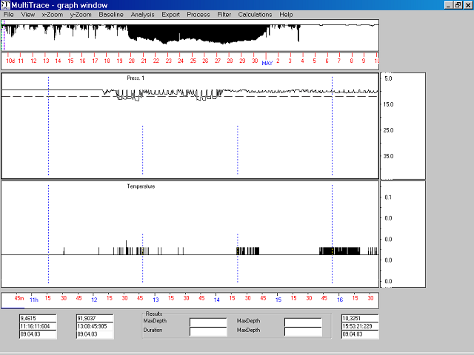
Click here or drag in-side.
Click inside the time axis

Fig 3

How to enlarge or to make smaller the visible section

Two pink continuous vertical lines (window border cursors) show in the uppermost window (in the overview graph) the set of data that is being shown in the sectional graphs in the lower windows. The pink lines are called the F1- and the F2-cursor. This section being displayed can be changed by means of the mouse or by the keyboard. Click at the border (Fig 1) or drag the border inside the window. By means of his operations you modify the size of the displayed section.
You can drag the pink cursor also in the overview graph.

You may alter the window borders by using the F1, F2 or F3 and the "arrow-keys". Press F2 and then the 'arrow-right' key a couple of times. The right border in the uppermost window moves stepwise further to the right while the left border remains stationary. Now press F1 and the 'arrow-right' key a couple of times. Note that both the time scale and the border lines in the overview graph changes.
The window enlarges or diminishes stepwise. You can alter the step by pressing the PgUp- and the PgDn-key.

The F3 key activates both borders simultaneously so that you can move along the length of your data while maintaining the length of the x-axis display of your sectional graphs constant. You can alter the length of the jumps made by using the 'page up' or 'page down' keys, 'page up' increasing the length of the jumps while 'page down' does the reverse. The length of the jumps is indicated by the horizontal line in the overview graph at the bottom of the time axis.

You can also move the visible section of the channel by a mouse click into the time axis of the overview graph or into the time axis of the section.

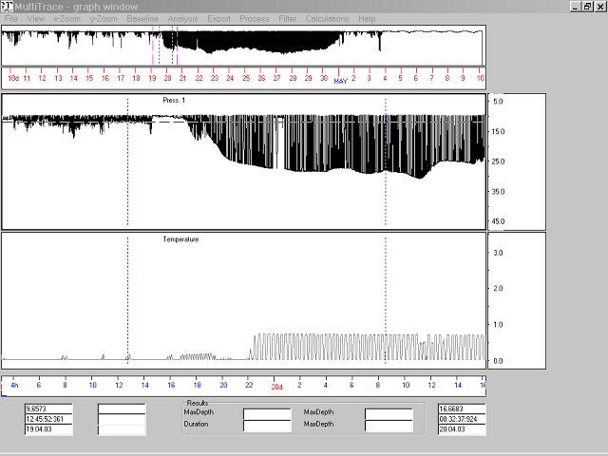
F4 and F5 (left, right cursor)
F1 (left border)
F2 (right border)

Fig 4 Changing the size of the visible section

The working cursors F4 and F5

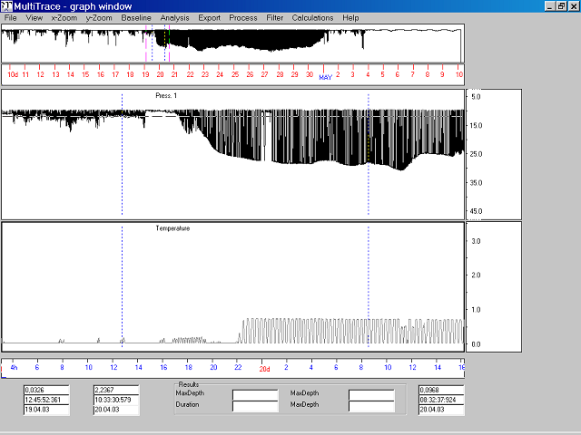
F4 cursor
F5 cursor

Fig 5 Moving the working cursors

If you select the menu item “X-zoom/Curs. into border” (short: Alt-X, then C or Ctrl-F6), two vertical dashed lines appear in the graphs. These are the working cursors F4 (left) and F5 (right). Almost all operations undertaken with your data take place between these two cursors. They can be activated to allow them to move by pressing F4 (left cursor), F5 (right cursor) and F6 (both cursors). They move by a press to the arrow left and the arrow right key and the speed with which they move is, as is the case with the border cursors, determined by the 'Page up' and 'Page down' keys.

The working cursor can be moved also by the mouse, either in the overview graph or in the sectional graph window.

Note that the working cursors can also be positioned outside the area shown in the sectional graphs, their position being shown in the overview graph. Mathematical operations on the data are invariably carried out between the working cursors, even when they are outside the sectional graphs.

How to browse through the channel page by page

The key combinations Ctrl+arrow-right (^->) and ^<- are working similar as the combination "F3 ->" or "F3 <-": The window borders F1 F2 will be moved together.
The behaviour of ^->, ^<- depends on the currently activated element. If the last pressed key had been either F1, F2 or F3 then the window borders F1 F2 will be moved together. F1 jumps to the position of F2 and F2 jumps forward, so that the adjacent graph section are displayed.

If the last pressed key was either F4, F5 or F6 before pressing ^-> then the behaviour is slightly different. The working area will move on. F4 jumps to the position of F5 and F5 moves forward. F1 and F2 will also move forward.

Using SHIFT and F3, both working cursors and borders can be moved together.

The text fields at the bottom of the screen

At the bottom of the screen there are prompted some numerical values.
Left hand is the y-value and the date and time of the current position of the F4-cursor.
Right hand is the y-value and the date and time of the current position of the F5-cursor.
If you press the left mouse button, then the current position and the time of the mouse appears in the middle.

Vertical Zooming
Click or drag inside
Click into the y-axis

Fig 6 Vertical zooming

Click into the scale, click at the upper or lower edge of the channel window to move the window up or down. Drag the upper or lower edge inside the window to zoom in.

By keyboard:
Press Ctrl+PgUp or Ctrl+PgDn. The graph in the uppermost sectional graph will be zoomed in or out. Press the 'arrow-up' and 'arrow-down' keys and you will note that the line in the graph moves up and down. Note that the actual values of the line in the graph do not change, the values on the y-axes moves synchronously up and down with the line. Thus, this zoom feature does not alter the data values in any way. What it does do, however, is allow you to view different y-sections of the graph or from a different scale perspective.

You may also zoom by the menu item “Y-zoom/Numerical” and then entering the limits for the y-axis in the sectional graph manually.

Max Zoom: Set the F4 F5 cursor to the section which you want to zoom maximal, then use “x-zoom/Bord. to Curs” (short: Alt-X then T). MT then will set the window borders F1 and F2 around the current working cursors F4 and F5, and in addition the data will be zoomed maximal.

Activation of the sectional graphs

The relevant sectional graph will be activated by a mouse click into the desired window.
Except for the positioning of the working cursors and the borders, all operations are performed uniquely in the activated sectional graph. In the overview graph, at the top of the screen, the full data series for the first selected variable will be shown. If you wish to have another graph displayed at this spot then simply activate the relevant sectional graph and select menu “View/Refresh total window”. The overview graph will then be redisplayed showing the zoomed area of the selected sectional graph.

Storing the settings in a configuration file

Use the menu “File/Save Settings” to store all the adjustments made in the main dialog and the parameters to analyze the data including the names of the data files. Later you can import this configuration file at the main dialog button “Read config. File” to restore these settings.

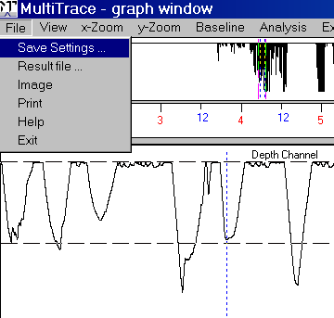

Fig 7 Select a config file to store the current settings

The other items in the file menu are to select a filename for the results of the analysis (you can select such a filename also in the menu “Analysis/Parameter”), for making a screenshot and for printing the current screen. Some explanations and hints are at the item “Help”.

Changing of the window height and data presentation

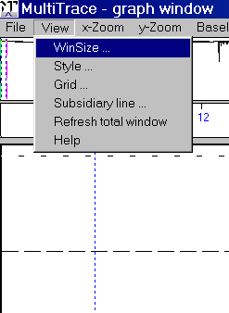  Fig 8 | WinSize. Alter the height of a channel window, so that it take up correspondingly more or less of the screen than other sectional graphs.If there is only one channel then this menu item has no effect  Style: Change the style of the displayed graph.  Normal Direction of the graph: High values top, low values bottom.  Inverted Direction of the graph: High values bottom, low values top.  Solid Data points (x,y) linked by solid lines.  Bars Each y-value rendered as a vertical bar at time x.  Dotted Each y-value rendered as a point at time x.  Note: 'Inverted' does not invert the data, only the graph!

Grid Lay a horizontal grid over the graph. Disable the grid by setting 'Grid distance' to zero.

Subsidiary line Define up to 10 horizontal help lines at any desired y-position. When setting the parameters for the analysis at the menu item 'Analysis/Parameters', MT automatically sets two subsidiary lines. One at the baseline (y=0) and one at the threshold. You may disable these help lines here.

Refresh total window Redraw the uppermost window which display an entire channel. Note that the currently active channel will be drawn at the total-window.

Moving the cursors and zooming in abscissa direction (time axis)

These commands are for changing the positions of the cursors and to move the current visible graph section (the area between F1 and F2). The current section can be also moved by a click into one of the time axes or by dragging the F1 and the F2 cursors by means of the mouse.

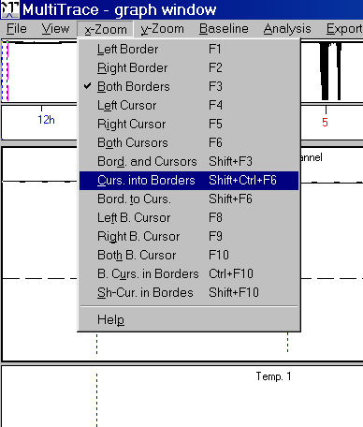
Fig 9 Moving the current visible graph section

Keys F1 ... F10 Press the key, then press the key left arrow or right arrow to move the cursor. Use PgUp-key and PgDown-key to alter the stepsize. All these elements can be moved also by the mouse. The keys F8 and F9 are the ‘bottom’ cursors: At the dive analysis they indicate the begin and the end of the bottom phase of a dive event.

Border and Cursor (Shift+F3) The borders F1 and F2 and the working cursors F4 and F5 will move together when pressing arrow right or arrow left. I.e. a next data section will be displayed and the working cursor will move along with the window.

Note that the combination Ctrl-arrow right and Ctrl-arrow left also moves the window (F1 and F2) ‘page-by-page’. See above “How to browse through the channel page by page”.

Curs. into borders (Sh+Ctrl+F6) The working cursors F4 and F5 will jump into the current visible graph section. That means that F4 and F5 jumps between F1 and F2.

Borders to cursors, zoom (Sh+F6) The visible graph section will move around the working cursors F4 and F5 (F1 jumps before F4 and F2 jumps after F5). Also the data section will be zoomed in (vertical) to the maximum.

Both Bottom Cursors (F10) Moves the “dive bottom phase” cursors F8 and F9 together.

Shift-Cursors into borders Jump the Shift-cursors into the current visible graph section window i.e. between F1 and F2. The Shift-cursors are not used for the dive analysis.

Zooming in ordinate direction (y-axis)

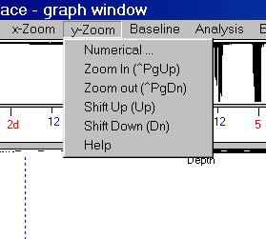  Fig 10 Zooming | Numerical. Zoom by typing in the desired minimum and maximum of the y-scale  Zoom in This can be achieved by the key Ctrl+PgUp.  Zoom out This can be achieved by the key Ctrl+PgDn.  Shift up Shift the graph upward. This can be achieved by the key 'arrow-up' or by clicking into the y-scale.  Shift down Shift the graph downward. This can be achieved also by the key 'arrow down' or by clicking into the y-scale.

Note that there are also these mouse commands for y-zooming (See Fig 6):

- Click on the upper border of a channel window to zoom out.
- Click on the lower border of a channel window to zoom out.

- Drag the upper border inside the window to zoom in.
- Drag the lower border inside the window to zoom in.

- Click into the y-scale.

Baseline trekking (zero offset correction)

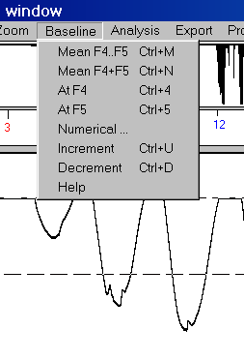  Fig 11 baseline trekking | There are several commands to adjust the baseline. All commands do the same; they add an offset to the data and in this way shift the data up or down.  This command affects the entire channel, not only the section between the working cursors F4 and F5.  Mean F4..F5 MT calculates the mean of all y-values between the F4 and the F5 cursor and sets the baseline (the new y=0 value) at this mean value. Move the working cursors F4 and F5 at a data section which should get an y-value =0 for instance to the surface of the water. Then hit Ctrl+M to adjust the data of the entire channel .  Mean F4+F5 MT calculates the mean of the two values at the F4 cursor and the F5 cursor and sets the baseline (the new y=0 value) at this mean value.

At F4 Sets the baseline at the y-value of the current position of the F4-cursor, so that y(F4) becomes 0.0.

At F5 Sets the baseline at the y-value of the current position of the F5-cursor, so that y(F5) becomes 0.0.

Numerical: Type in the y-value which shall become the value 0.0.

Increment (Ctrl+U) Shift the baseline downward. The step size depends on the current y-zoom.

Decrement (Ctrl+D) Shift the baseline upward. The step size depends on the current y-zoom.

The advantage of the last three methods is that it is not necessary to move the working cursor to a sufficient location. For many analyses “Mean F4 F5” is a sufficient method to initially adjust the baseline: Move the working cursors F4 and F5 at a data section which should get an y-value =0 for instance to the surface of the water. Then hit Ctrl+M to adjust the data of the entire channel .

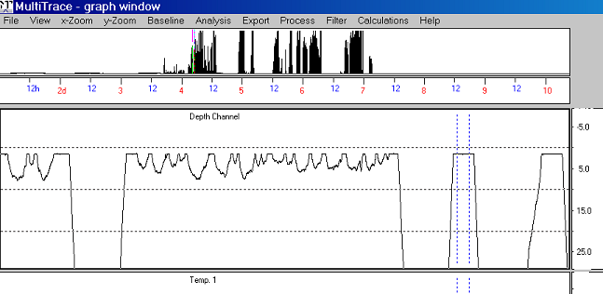

Fig 12 Before baseline trekking

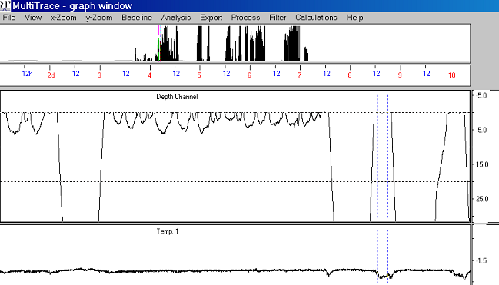

Fig 13 After baseline trekking

(The ‘Analysis’ chapter is at the end of this manual)

Export

This option is related to all operations that are concerned with writing data onto the hard disk. Before writing any data onto the hard disk, however, MultiTrace checks that no files already exist that have the suggested name. If this is the case you will be asked to supply another name.

You may export sections of the data or the entire channel into a file onto the harddisk. The data of each channel can be exported into a text file including time information or into a binary file.

A binary file is smaller than a text file and much faster imported by MT. Thus, if there is to load a large data file (text file) at several MT-sessions, then it may be recommended to export the entire channel as a binary file and subsequently load this binary data file in order to spare time.

The data in the working area can be stored on the hard disk in binary format. This means that data can be readily 'cleaned up'. For example, if you have a data set where the last third is considered worthless for some reason, you can set the working cursors to encompass the good section and export the data into another file. By so doing you will obtain an exact copy of your original data minus the worthless part.

The binary files exported by MT contain additional information about the data such as sampling rate and start time. That’s why you can select “Read header” at the main dialog in case you are going to load a binary data file. In this case MT reads these information from the file and overwrites the settings at the main dialog.

Generally the export into a file is important if you have changed the data (e.g. data smoothing) and you want to safe your work for the next MT session. For the analysis of data it is not necessary to export any data.

Export of the channel data into a text file

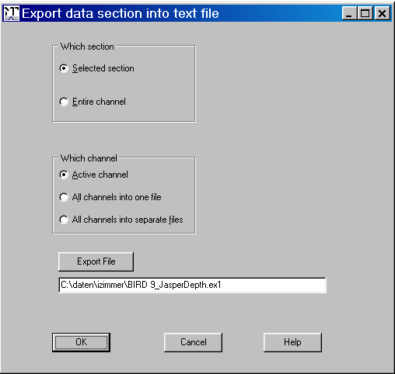

Fig 14 Export into a text file

Here the data are converted into their ASCII physical values (those displayed on the y-axis of the graphs shown on the screen) which are stored together with the exact time and date at which they were recorded. Note though, that ASCII data take up approximately 25 times more place on your hard disk than do the equivalent binary data!
It is also possible to export all channels into one table. First values of all channels into the first line of the table, 2nd values of all channels into the 2nd line, and so on. Please note that different sampling rates (e.g. channel1=3 sec, channel2=5 sec, channel3 = 2 sec) will not supported.

Selected Selection. Export only the data between the working cursors F4 and F5 into the text file.

Entire channel: Export the entire channel text formatted.

Active channel. Export only the data of the active channel.

All channels into one file: Export the data of all channels into one text file column by column. The sampling rate must be the same for all channels.

All channels into separate files Export the data of all channels into separate text files

Export of the channel data into a binary file

Here it is possible to store the data binary formatted into files. This is useful if your text formatted data files are very large and it is time consuming to load them. Use this feature to convert them into binary format and to store them. At the next MT-session load the binary files, this is much faster than loading text files.

Hint: If you have performed specific operations at the data (e.g. baseline trekking, multiplying the data, applying polynomial,..) then you should save the modified data as text files, since it is not possible to store all modifications made at the data in a binary file

For the same reason it is not allowed to do some operations successively e.g. apply a polynomial, then add a const offset. Export the data as text and reload before performing the next operation.

You may include a comment of max 2 x 70 characters into the header of the binary file to create.

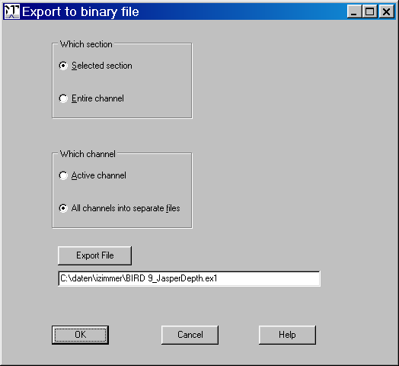

Fig 15

Selected Selection. Export only the data between the working cursors F4 and F5 into the text file.

Entire channel: Export the entire channel to a binary file.

Active channel. Export only the data of the active channel.

All channels into separate files Export the data of all channels into separate binary files.
The extension of the files will be replaced by 000, 001, 002,…
Example. If the name of the “Export file” is ‘depth.ex1’ then the three output files will be named depth.000, depth.001 and depth.002 (in case there are three channels)

Processing the data

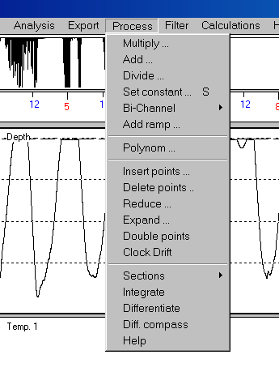  Fig 16 | Here you can modify the data of each channel. You can for instance set a section of the data to a constant value or correct a timing error.  The operations modify the y-values of the activated channel irreversible. However, the original file will be not affected, only the copy of it inside the computer-memory will be changed. Store the modified channel in a file (Menu 'Export') to make the modifications persistent.  Add Add a value to the y-vales of a section of the activated channel. To add a value to the data of the entire channel, set the F4-cursor and the F5-cursor at the begin resp. the end of the channel (F4, Home-key, F5, End-key), then select 'Add' of this menu.  Multiply Multiply the y-vales of the activated channel by a constant. To multiply the values of the entire channel, set the F4-cursor and the F5-cursor at the begin resp. the end of the channel (F4, Home-key, F5, End-key), then select 'Multiply' of this menu.

Set Constant Set the values between the F4 and the F5 cursor to a constant value.

Add ramp Add a ramp to the y-values of the working section.

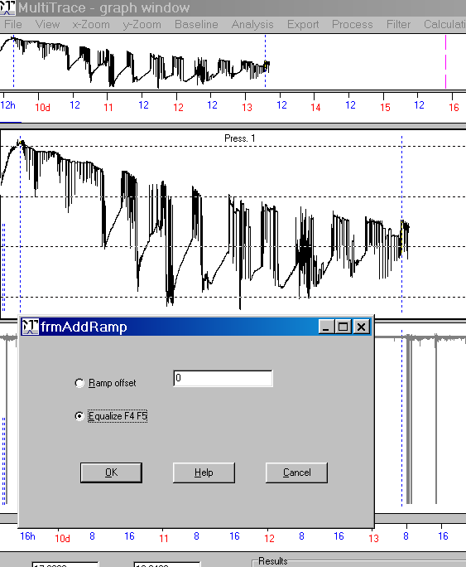
Before adding a ramp

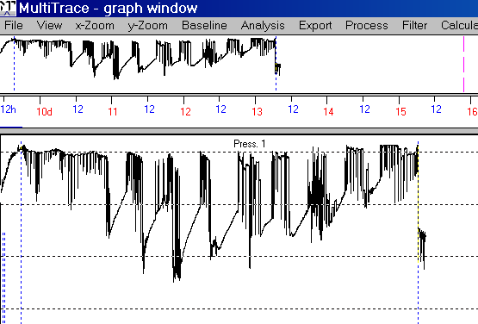
After addition of a ramp

Note: If you don't select the entire channel but only a section of the channel (F4 and F5 are not at the begin and end of the channel but somewhere inside) then the operations above (Add, Multiply, Divide, Set Constant, Add ramp) cannot lead to results which exceeds the limits (range) given in the 'Scaling' box of the main dialog.
In this case you have to exceed the range:
1) Data file is text file: Leave MT, start it again, disable 'Auto scaling', and set the limits min. and max. so that the results of 'Add', 'Multiply, 'Divide' fits into this range. Disadvantage: Extending the range leads to a decrease of resolution.
2) Data file is a binary file: Export the entire channel as a text file (menu 'Export/Text file), then perform the steps of 1)

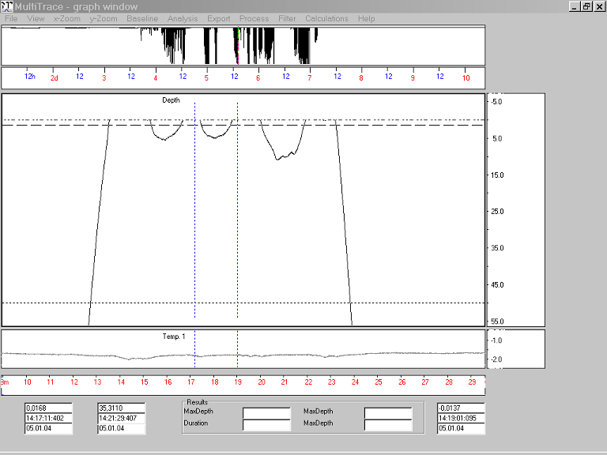
Fig 17 Before adding a constant offset
(Here the height of the temp. window is reduced by “View/WinSize” )

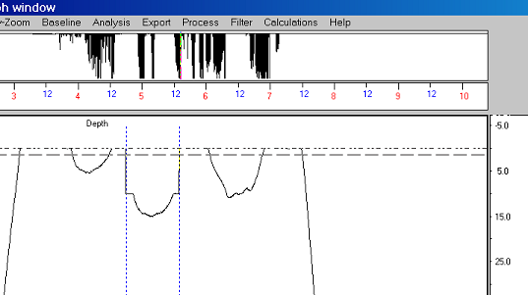
Fig 18 After adding a constant offset

Bi-channel operation
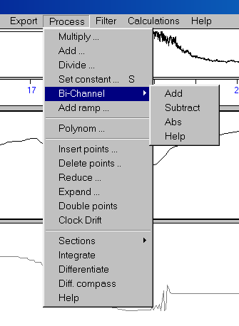 | Add or subtract the values of one channel to those of another channel. This operations concerns the entire channel. The sampling rate and the start time of the channels must be the same.  Add Add the values of one channel to those of another channel (Channel3 = Channel1 + Channe2)  Subtract Subtract the values of one channel to those of another channel (Channel3 = Channel1 - Channe2 )  Abs Build the sum of two channels, then calc. the absolute values of the sums. (Channel 3 = abs(Channel1 + Channel2). Absolute function: abs(x) = x if x positive , abs(x) =-x if x negative.  Example: abs(-5)=5, abs(5)=5

Polynomial
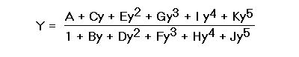
Apply the polynomial above to the data.

with
y The current phys. value (e.g. meters) before applying the polynomial.
Y The resulting values after applying the polynomial.
A,..K The coefficients of the polynomial.

to the data of the current channel. This operation is reversible: If you disable the checkbox 'Apply polynomial' then the data will appear as before applying the polynomial.

When applying a polynomial, some operations are not usable any longer: Baseline operations and all kind of arithmetical operations such as adding values or multiplications. If you although need to perform such an operation, there are two ways.

1) Modify the polynomial equation in an apt manner. In case you want to multiply the y-values by a constant X, then multiply the coefficients A, C, E, G, H, J by X. In case you want to add a constant X, then modify the polynomial equation by equalizing the denominators. Example: Assume the current polynomial is of this form

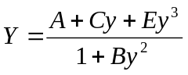

and you want to add the constant 5 to this polynomial.

+ 5

= 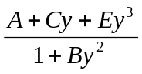 + 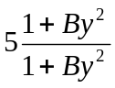

= + 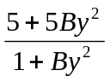

= 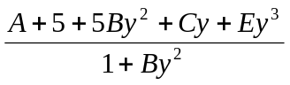

2) The second way is to apply the polynomial, then export the entire channel as a text-fie (not as a binary file), then leave MT and load the just created file into a channel. Disable the checkbox 'Apply Polynomial'. Now you can modify the channel in the usual way (baseline trekking, adding values etc.)

The following procedures (Insert, Delete, Reduce, Expand) changes the number of data points of a channel. Since MT calculates the time information by the position of the data points, these operations effects the time scale and should be used carefully.

Insert points Insert a user defined amount of data points right hand of the F4-cusor. The y-magnitudes of the new points will be the same one as the y-value at the F4-cursor.

Note that this operation corrupts the time scale. Example. Assume the channel consists of 100 points and the sampling interval (SI) is 10 sec. Then e.g. the last data point is assigned to the time 1000 seconds after start time. If you insert somewhere 50 points, then the time of the last point would be now 1500 seconds after start time.

Delete points Delete all data points between the F4 and the F5-cursor. Note that this operation corrupts the time scale in a similar way than 'Inset points' does it.

Reduce This operation effects the entire active channel. The amount of data points will be thinned out. Example: ThinOutFact = 3 -> Let each 3rd data point remain, delete the other data points. The sampling rate will be multiplied by ThinOutFac.

Expand This operation effects the entire active channel. The amount of data points of the active channel will be extended. Example: ExpandFactor=3 -> Insert two points between each two adjacent data points. The sampling rate will be divided by ExpandFactor so that the time scale remains constant. The new data points will be included by interpolation.
Example: y-values before expanding: 1 4 10 4 ....
After expanding (ExpFac=3) 1 2 3 4 6 8 10 8 6 4 ...
Expanding is as artificially decreasing the sampling rate of a channel.

Double points This operation is similar as 'Expand' (above). In opposite to 'Expand' the number of inserted points is fix: the amount of data will be doubled. There will be inserted one point between each two adjacent data points. This additional point will be inserted by a nonlinear interpolation.
You may repeat this operation thus achieving an amount of four times, eight times,.. data points. This operation requires an even sampling rate e.g. 1000 msec. An odd sampl. interval such as 999 msec is invalid for this operation.

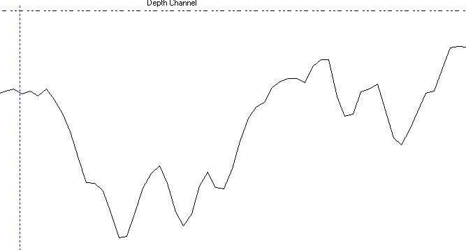
Fig 19 Before doubling points

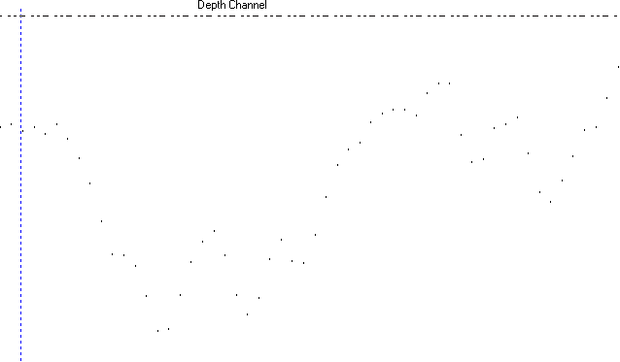
Fig 20 The same as Fig 19. Here the graph is displayed dotted (menu “View/Style -> Dots)

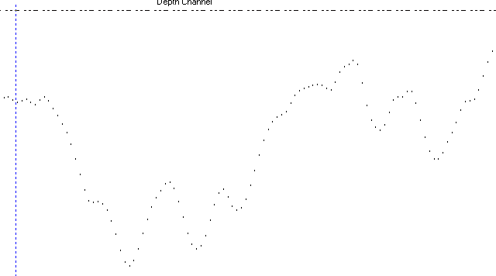
Fig 21 After ‘Double Points”. Between every two points there is inserted a new point by nonlinear interpolation.

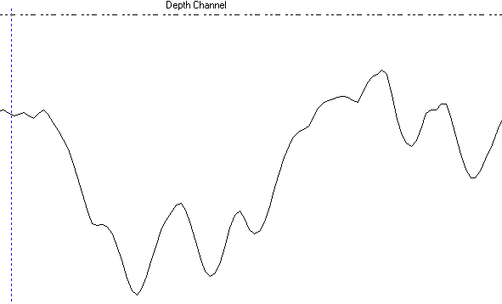
Fig 22. Same as Fig 21. The graph is displayed again as a solid line.

Clock drift: This operation corrects timing errors and it is mainly important for analyses that needs exact time information such as light analysis (geolocation). The logger’s on-board clock (RTC) may had worked not absolute correctly so that the time information is wrong e.g. the time of the last recorded data is 12:00:00 but in fact it was at 12:00:06. Use this feature to correct such timing errors.

If the time drift is large, this procedure cancels prompting “Operation rejected. Adjust the original sampling rate…” This means that a clock drift correction by this procedure is not necessary. Firstly increase or decrease the sampling rate (in the main dialog of MT) to achieve a better accordance of real time and RTC clock. If the achieved results by changing the sampling rate are not sufficient, then use subsequently “Clock drift”.

The time interval to add or to subtract (“Correct RTC drift by:”) must be at least one sampling rate. (You may decrease the sampling rate artificially e.g. by menu “Process/Expand” to obtain a smaller sampling rate.)

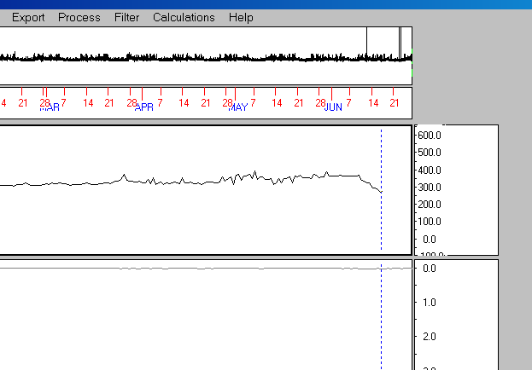

Fig 23 Before RTC correction. At the upper channel the clock run too slowly at recording time. At the end there is a ‘lack’ of 6 minutes

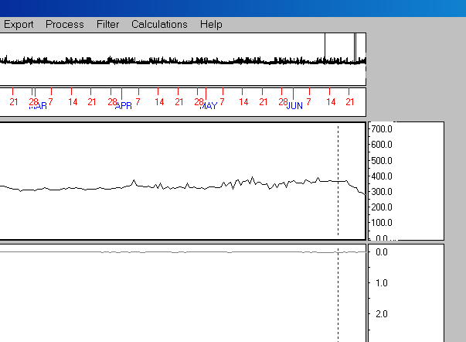

Fig 23 After RTC correction. MT “stretches“ the data, so that time information is correct now.

Sections To store data sections (between F4 and F5) of a channel into a buffer and to copy this section to another location of the channel. This feature may be helpful for instance for the light analysis (geolocation). One can repair corrupted data sections which are necessary for the data analysis.

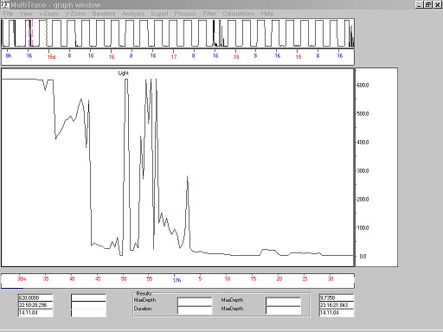
Fig 24 This are light intensity data. The sun set section is damaged

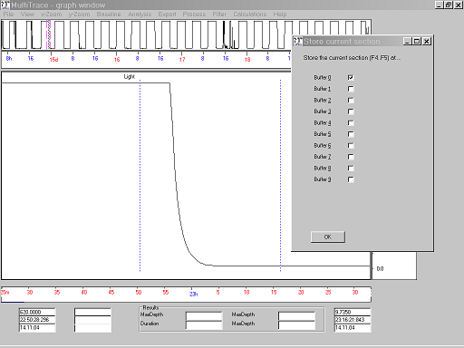
Fig 25 Select a section of the neighbourhood (e.g. next sunset) and store it into a buffer.

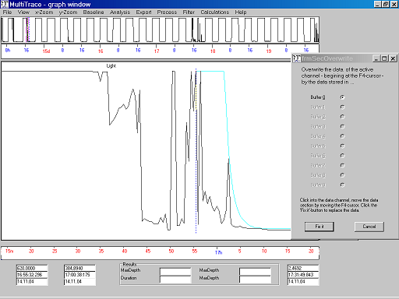
Fig 26. Return to the damaged data section and overlay the good section of the buffer.
You can move the buffered section under full visual control to the apt location.

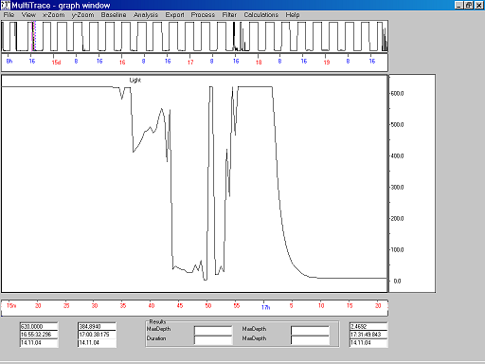
Fig 27 Overwrite the bad data by the good one.

Integrate Integrate over the entire channel.

Differentiate Differentiate over the entire channel.

Diff. compass Differentiate over the entire channel, but regard the values as directions of the range [0..360]. Examples: 60-20 =40, 20-350=30, 300-20=-80

Filtering the data

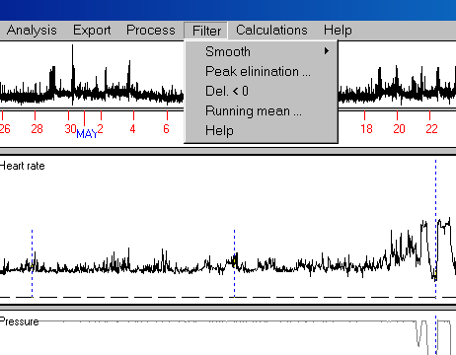
Fig 28 Filter menu

Smoothing data

Here, the data between the two working cursors are smoothed according to the function
y(n) = y(n-1)/4 + y(n)/2 + y(n+1)/4
y(n) = [y(n-3) + 2*y(n-2) + 4*y(n-1) + 10*y(n) + 4*y(n+1) + 2*y(n+2) + y(n+3) ] / 24
y(n) = [y(n-3) + y(n-2) + 2*y(n-1) + 3*y(n) + 2*y(n+1) + y(n+2) + y(n+3) ] /11

Note: Multiple smoothing is possible. Smoothing is an irreversible operation.

/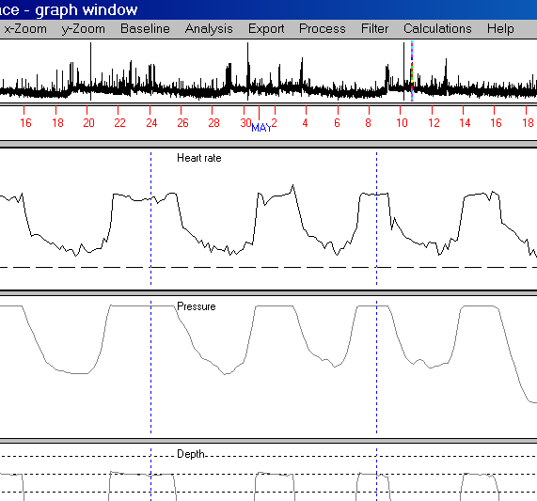
Fig 29 Before smoothing the working area

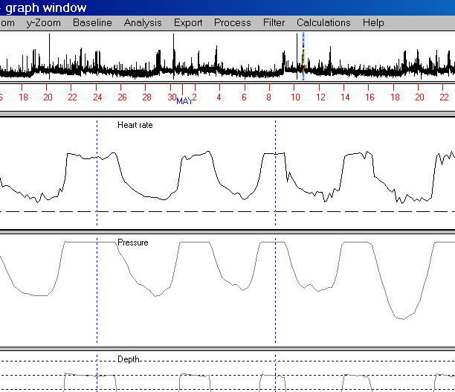
Fig 30 After smoothing the working area

Eliminate peaks By means of these procedures it is possible to delete peaks. In fact peaks will not be deleted (data points will not deleted) but replaced by other y-values. Thus the amount of data points remains constant. All peaks at the working area (F4…F5) will be deleted.

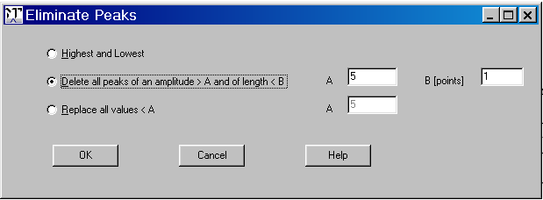
Fig 31 Dialog to eliminate artefact peaks

Highest and lowest Replace the absolute highest and lowest values. These are the greatest and smallest values the data logger were able to store. This operation is useful if the logger didn't work perfectly and sometimes erroneously stored the most extreme possible values.

Delete all peaks amplitude >A, length <B User defined peak elimination. Define the peaks to delete by their amplitude A and their length B. Peaks of a smaller amplitude than A will be not deleted as well as peaks of a duration >= B. The unit of B is points (sampl. intervals) not msecs. Example to explain 'Amplitude': the data series -6, -6, -6, -16, -6. -6 contains a peak of amplitude 10 and of length=1.

Replace all values <A Replace all data points which are smaller than A by interpolation.
Example: y-data: .. 49 48 50 0 0 0 0 20 19 17 ...
After replacing all values < 10:
y-data: ... 49 48 50 44 38 32 26 20 19 17 ...

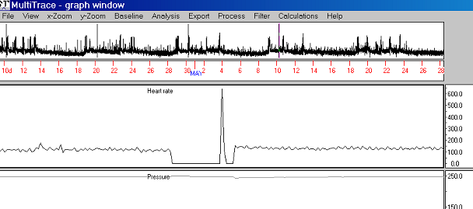
Fig 32 Before peak elimination

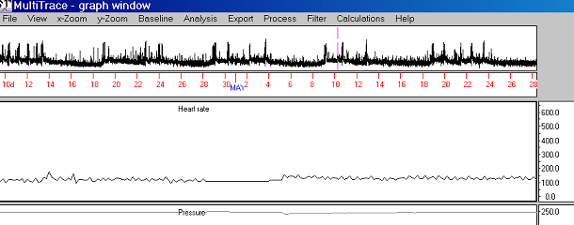
Fig 33 After peak elimination

Del <0 Delete all y-values that are smaller zero. By baseline trekking you can achieve to delete also all y-values that are smaller than any given value.

Running mean Replace y(n) by the mean of the last n y-values. The running mean can be only displayed as an overlaid graph, not exported into a file. Erase the running mean by setting RunMean=0.

Some helpful calculations

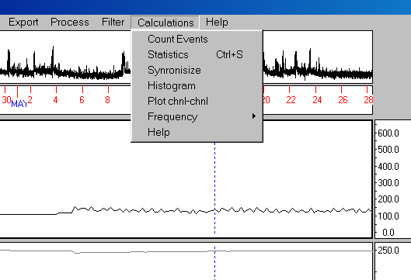
Fig 34 Menu calculations

These operations does not modify the y-values of any channel.

Count Events When calling this item you will be asked to enter a 'Threshold'. MT then counts all crossings of this threshold between the F4 and the F5 cursor. Use this feature to get a fast overview of the amount of e.g. dive events. Note: This feature does not search begin and end of a dive event such as the dive analysis does it, it simply counts the crossing and re-crossing (cross and re-cross is one event) of the graph with the threshold-line.

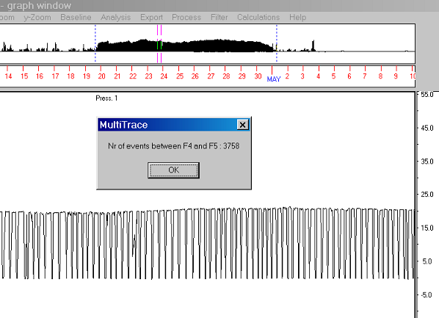
Fig 35 Counting events

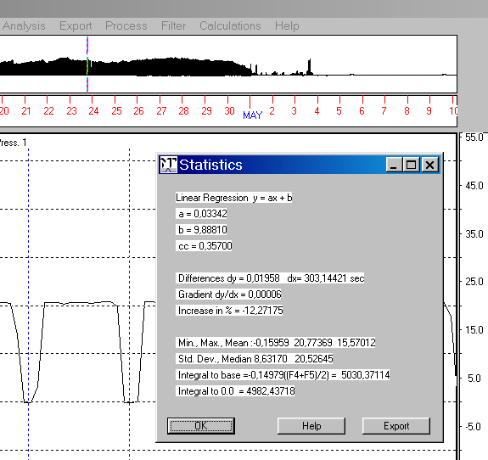
Fig 36 Some statistics

Statistics Calculates some statistics (min, max, mean,..) on the working area.
Export button: To export the statistic-values into a text file.

When pressing this button, a filename will be prompted which may be modified. If this file yet does not exist, MT creates a text file of this name and exports the values listed below into this file. If the file already exists, the statistics will be appended at this file.
There is no proof whether the current file is suitable. It is in the responsibility of the user not to destroy an important file by appending statistics.

- Time and date at F4
- Time and date at F5
- Duration t(F4)..t(F5)
- Minimum y-value
- Maximum y-value
- Mean y-value
- Standard deviation
- Median y-value
- Coeff A of Lin. Reg. y = A t + B (t time)
- Coeff B of Lin. Reg.
- Coeff CC of Lin.Reg.
- dy y(F5) - y(F4)
- dx t(F5) - t(F4)
- Gradient dy/dx
- Raise Increase y(F5) to base y(F4) as percent
- Integral Integral related to the baseline [y(F5) + y(F4)] / 2
- User comment

Synchronize This operation helps you to fit two channels in time by changing the sampling interval (SI).

Example: Assume there are two channels and apparently the sampling intervals (SI) of channel A is not correct, perhaps because the internal clock of the device did not run exactly. If it is possible to detect in channel B a time position t2 which actually should correspond to a time position t1 in channel A, then set the F4 and the F5 cursor at t1 resp. at t2 and call 'Synchronize'. MT asks you which channels are to compare and then calculates four possible SIs: SI11, SI12, SI21, SI22:
If you set channel A to SI11, then t1 moves to t2 in A
If you set channel A to SI12, then t2 moves to t1 in A
If you set channel B to SI21, then t1 moves to t2 in B
If you set channel B to SI22, then t2 moves to t1 in B

To change the SI, leave the graphic module of MT and enter the new SI at the main dialog.

One important note to binary files: Binary files may contain a header, containing the start time, sampling rate and some more info. If you have changed the sampling rate at the main dialog, then set the option "Read header" to "No". Else MT would take the sampling rate of the file header when importing the binary file. When having imported the file, you may create a new binary file with altered heading information.

Histogram Here, a frequency distribution is calculated for the data between the working cursors and this distribution stored on the hard disk as a text file. You will be asked for the size of the bins, the lowest bin and the name of the histogram file (to store the histogram). The maximal number of bins is 255.

Example: Assume your data (y-values) range from 0... 800. If you choose "binSize=2" and "Lowest bin = 100" then the bins will be:
100..102
102..104
: :
606..608
608..610
In this case all data < 100 and all data > 610 will be not taken into the histogram table.

The histogram function also calculates:
- the mean,
- the standard deviation and
- the median
of all values (also of those laying outside the histogram table, in this example <100
and > 610) and export these magnitudes into the histogram file.

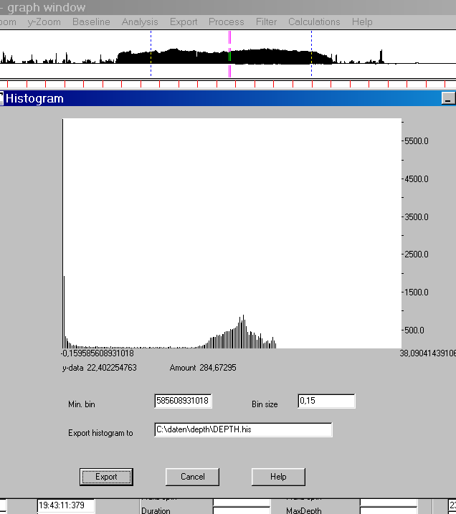
Fig 37 Histogram

Begin: 21.04.2003 12:27:04 End: 29.04.2003 23:31:52 Duration [sec]: 731087392
< -0.01 6092
-0.01 - 0.14 1942
0.14 - 0.29 350
0.29 - 0.44 277
0.44 - 0.59 211
0.59 - 0.74 174
0.74 - 0.89 152
0.89 - 1.04 102
1.04 - 1.19 105
1.19 - 1.34 93
1.34 - 1.49 109
1.49 - 1.64 84
1.64 - 1.79 76
1.79 - 1.94 85
1.94 - 2.09 75
2.09 - 2.24 72
2.24 - 2.39 55
2.39 - 2.54 76
2.54 - 2.69 65
2.69 - 2.84 64
2.84 - 2.99 73
2.99 - 3.14 55
3.14 - 3.29 62
3.29 - 3.44 57
3.44 - 3.59 49
3.59 - 3.74 69
:
:
:
37.49 - 37.64 0
37.64 - 37.79 0
37.79 - 37.94 0
37.94 - 38.09 0
> 38.09 0

Mean: 12.94 Standard Dev.: 9.01 Median: 17.54

A histogram file (a section in the middle discarded)

Frequency Searches local minima and maxima between the working cursors F4...F5, tags them and calculates
- the average of the minimal values.
- the average of the maximal values.
- the frequency in Hertz.

When you select this menu item, you will be asked for the 'Sensitivity'. The greater you set this value, the less local extrema will be found and vice verse. Exactly: MT searches all local extrema of an amplitude > Std Dev * Sensitivity, whereas 'StdDev' is the standard deviation of the data section enclosed by the F4- and F5-cursor.

Also a text file named 'extrema.txt' will be created containing 6 columns: Onset, y-value, amplitude, integral (from last min. to current min.), frequency at the current phase and kind of extremum . This file will be stored in the folder of the current active channel.

This feature is useful for data in waveform, such as data of an acceleration sensor which had recorded e.g. acceleration induced by steps or wing movements.
The command “Dispose tags” deletes the tags which marks the extrema (minima and maxima). The command “Show results” pops up a window showing again the averages of minima and maxima and the calculated frequency.

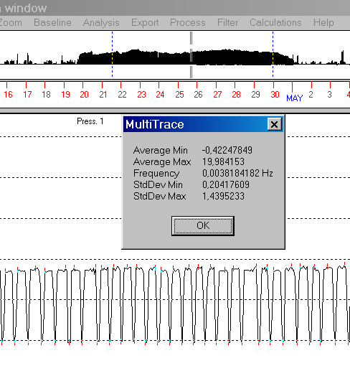
Fig 38 Frequency calculation

Plot channel-channel Creates a plot of channel 1 against channel 2 and enables to adjust the baseline of these channels. This command is useful for the route calculation by compass values. The channels must be of identical sampling rates.

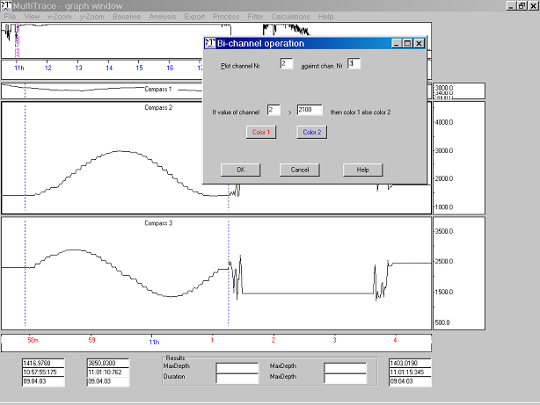

Fig 39 Plot channel against channel
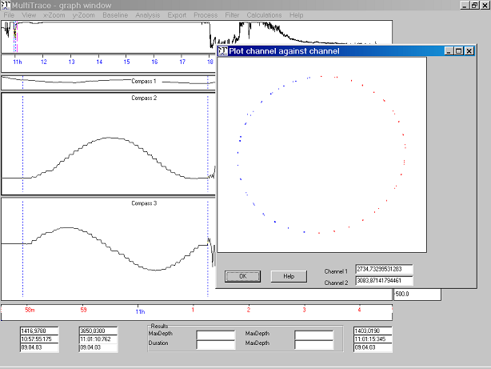
Fig 40 Plot channel against channel

II. The Analysis module (dive)

The analysis module provides specific functions for the analysis for a diving animal. The graphs considered are: dive depth data. The graph for depth values is analysed for specific diving elements e.g. dive durations, rates of change of depth etc.

The dive analysis expects positive values i.e. swimming at the surface should be represented by y=0 and diving phases should be represented by positive y-values. In case your data are vice versa (negative values for diving phases) then invert the entire channel: Set the F4 and F5-curosr at the begin and the end of the channel ("F4", "Home", "F5", 'End"), then multiply the entire channel by -1 (Menu Process/Mutlipy).

In case the baseline is yet not set to zero then adjust the baseline as described below in "Tips on conducting a successful analysis"

Activate the depth data by a mouse click into the appropriate graph. Before a dive-analysis is undertaken, however, various parameters must be specified (Menu Analysis/Parameters) according to the users precise analysis wishes.

The criteria for what constitutes a 'bottom phase' in a dive are based around looking for a point of inflection in the depth profile. Dives with a clear bottom phase in them consist of a descent phase (with usually constant rates of descent), followed by a point of inflection where the animal flattens out (although it may continue down slightly or even rise). This basic second trajectory is then followed for a while before a second point of inflection is followed by an ascent to the surface which marks the end of the bottom phase. Of note are parabolic dives, which have no point of inflection (and are, by definition, therefore not U-shaped dives anyway) and, of course, V-shaped dives where the point of inflection results in a phase which takes the bird back to the surface.

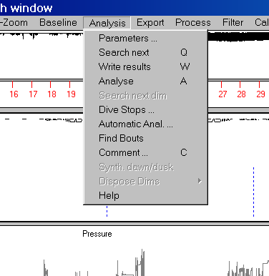
Fig 41 Menu Analysis

Parameters Open a dialog to get all settings for the analysis e.g the threshold. This dialog contains more information about the various parameters.

Search next Press 'Q' to let MT search the next event after the current position of the F5-cursor according to the settings at the menu item 'Analysis/Parameters'. Use this command to proof whether your settings are set properly to find dive events before you start exporting the results (the dive characteristics). Also use this command to ignore an event.

Write results Press W to let MT analyse the current dive event, export the results into the result file and search the next dive event.

Analysis Press A to force MT to analyze again the current event. This may be helpful if you have changed one of the borders (‘begin of dive’ or ‘end of bottom phase’). MT searches again dive stops and wiggles according to the new borders. ( wiggles outside the bottom phase will be ignored.)

You may change the dive stop events by the mouse (drag the dive stop border) or by the menu ‘Analysis/Dive Stops’. Attention: If you firstly change a dive stop and then press A, all your modifications at the dive stops will disappear since MT re-searches the dive stops.

Dive Stop When MT detects one or several dive stop, then you can modify the dive stops here.

Automatic Analysis: Here it is possible to launch an automatic analysis. MT performs an analysis of the working section (F4 .. F5). All events inside this section will be found and the results exported into the result file. This is a very fast method to analyze a data file, but is only recommended for very large files of good data quality since the user cannot intervene into the process till the section is worked out.
Perform the steps 1), 2) and 3) of 'How to analyse dive data', then set the F4 and the F5-cursor around the section to analyse and call this menu item. Press the button 'OK' to start the autoAnalyse.

Find bouts Let MT find a series of dive events. MT only searches and views the bouts, there is no analysis at this stage. Set the dive parameters in the same way as for 'Search next'.

Comment You may type in a comment to the current dive event. The comment will be appended to the current results i.e. it will be appended at the line which contains the characteristica (maxDepth, DurationDive,...)of the current dive event.

The parameters for the dive analysis

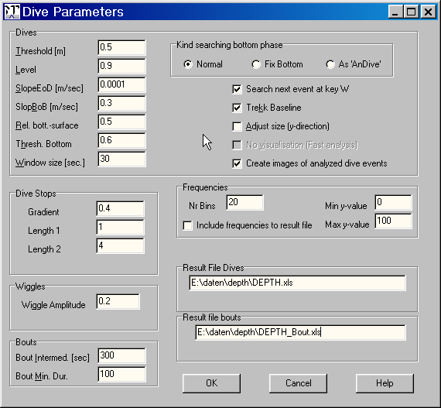
Fig 42 The dive parameters

The following parameters concern the detection of the end of a dive and the start and end of the bottom phase of a dive (for definition of these see Le Boeuf et al. 1988). Only when the user is dissatisfied with the way MultiTrace detects these should he/she attempt to alter carefully the suggested parameters.

Dive threshold T. Each dive event that max. depth does not exceed T meters will be ignored by MT. This threshold value allows the program to determine when a dive is considered to have taken place and represents a specific depth below which the animal is considered to have been at the surface. For example, if 60 m is given as the threshold, then MultiTrace will only consider as dives those one which exceeds 60 m. Note that the threshold can be set to different values for each displayed graph.

Level L Criterion to detect end of diving:
End of the dive when the animal has exceeded a certain percentage of the maximum recorded depth for that dive. For example, when Level EoD = 0.95, and the considered dive has a maximum depth of 100 m, then the end of the dive will be suggested at the point where a recording was made when the animal was within 5 m of the surface.

Slope EoD S Criterion to detect the end of diving: End of dive event if the current gradient is smaller than the value, defined by "S" [m/sec]. Example: S= 0.2: MT sets the end-of-dive-cursor (F5) when the vertical velocity of the animal is smaller than 0.2 m/sec. S is also used to detect the onset of the dive. It is used in reversed manner then.

The value S defines the begin and the end of the dive event (the settings of the F4- and the F5-cursor). The F5 cursor is set at the time position, when the vertical speed [m/sec] of the animal is smaller than S.
Example: S = 0.3 m/sec. Regard the diving up phase of the animal: Let's say the animal dives up with a mean vertical speed of 1.5 m/sec. At the time t0 when the vertical velocity is samller than 0.3 m/sec then t0 is assumed to be the end of the dive phase and the F5 cursor is set at t0. For the setting of the F4 cursor (the begin of dive) the equivalent is true.

Generally a value S of zero or slightly positive (0.1) is a good choice. The more positive S, the more the F4- and F5-cursors are sliding into the diving event, the smaller S is, the more spreaded will be set the F4- and F5-cursor.

Note: MultiTrace assumes an end-of-dive only if both criteria L and S are valid !

Both parameters L and S define the begin and end of a dive. L describes a threshold oriented criterion, S a gradient oriented criterion to detect the begin and the end of a dive event. The criteria are linked by an AND-operation i.e. if the L criterion and the S criterion is fulfilled at a time t0, then MT assumes that at t0 is the end (or the begin) of the dive event. If you want that only one criterion should be used to detect begin and end of a dive event, then set the other parameter to a value, so that it is always true. Example: Assume you want to detect begin and end of the dive only threshold oriented, irrespective of the gradient criterion. For this purpose set S to -1000. The animal dive up always with a vertical speed greater than -1000, so this criterion will be always true and end of diving will be detected as soon as the L-criterion is fulfilled.

SlopeBoB B To detect the end of a bottom phase: End of bottom phase, if the dive gradient is smaller than B. Example: B=0.3 => Begin of bottom phase, if the vertical speed is smaller than 0.3m/sec.
The value B defines the onset and the ending of the bottom phase (the settings of the F8- and the F9-cursors). The F8 cursor will be set at the time position, when the vertical speed [m/sec] of the animal is smaller than BoB.

Example: B is set to 0.2 m/sec. Regard the diving down phase of the animal: Assume the animal dives down with a mean speed of 1.5 m/sec and assume that at the time t₀ the animal begins to dive less steep, only 0.2 m/sec. Then t₀ is assumed as the begin of the bottom phase. For the setting of the ending of the bottom phase the equivalent is true.

If 'Kind searching bottom phase' is set to 'Fix. Bottom' this parameter will be ignored'.

Relation Bottom-Surface R:
Concerns the detection of the bottom phase: Bottom diving (U-form) exist if: (Duration BottomDive)/(TotalDiveDuration) > RelBotSrfc, where "Duration BottomDive" is defined as the time, which is spend below 'Threshold bottom' (see below) by the animal. Default value of R = 0.5. This option affects the identification of U-shaped dives.

If 'Kind searching bottom phase' is set to 'Fix. Bottom' then this parameter will be ignored.

Threshold bottom H
Only valid if 'Kind searching bottom phase' is set to 'Normal': Criteria for the existence of a bottom phase.
Example: Max depth of current dive= 200 meter and H= 0.75: If there is a bottom phase less then 0.75*200m =150m, then this bottom phase will be ignored. Default value of H= 0.6.
Note that the ‘Threshold bottom’ effects the detection of the bottom phase. If necessary change also the ‘Relation Bottom-Surface’ when changing ‘Threshold bottom’.

The bottom phase of a dive is not only defined by a particular rate of change of depth, it can also be defined by a particular minimal depth with respect to the maximum depth recorded for any particular dive. For example, if the maximum depth recorded for a particular dive were 100 m and BotThr is set to 0.6, then the bottom phase of the dive profile would be considered to occur at a depth of 60 m. In this case that means: If MT detects a bottom phase at 50 meter, then MT will reject it and MT will set the value "duration bottom dive" to zero and set the F8 and F9 at the time of the maximum depth.

If 'Kind searching bottom phase' is set to 'Fix. Bottom' then the parameter H will be interpreted as explained at 'Kind searching bottom phase'

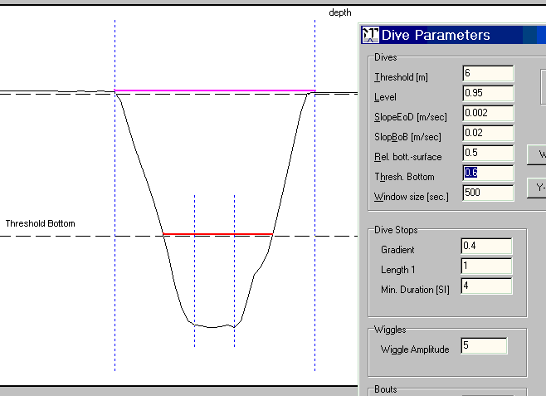

Fig 43 “Threshold Bottom” and “Relation Bottom-Surface” controls U- and V-shape identification.
Here the Threshold Bottom parameter is set to 0.6, thus 60 % of max depth, indicated by the dashed line in the middle of the picture (It is made here visible, generally it is not visible). Relation bottom surface is set to 0.5. That means: If the section of Threshold Bottom that cuts the dive (the red line) is shorter than 50 % of the entire dive duration (the pink line), then it is a V-shaped event, else an U-shaped event.
To obtain more V-shapes increase “Relation bottom surface” or decrease ‘Threshold bottom”.

The parameter SlopeBoB (slope begin of bottom) controls the setting of the bottom cursors in case U-shape had been identified. This is a gradient method. The bottom cursors will be set where the current gradient of the dive is smaller than SlopeBoB If you choose a low SlopBoB then the bottom cursors will move more into the dive i.e. the bottom phase will decrease If you choose a higher SlopBoB then the bottom cursors will move more out of the dive i.e. the bottom phase will increase.
Estimate a good value for SlopeBob by means of the mouse (select checkbox ‘Diff’) or by menu ‘Calculations/Statistics’. (Before set F4 and F5 at the ascent or descent phase of the dive.)

Window size W The horizontal size (x-axis) of the window to show the current event. If the current event is too large, then W will be temporarily increased automatically. Units of W are sampling rates not seconds or msecs!
After having found a particular dive event MultiTrace displays the event in a special window. By pressing W at this point, the user can define the temporal length that this window should have. For example, imagine that you have have selected a window size corresponding to 300 recordings, each recording being logged once every 8 secs, then the window in which the event is displayed will have a total time axis of 2400 s or 40 min. Each subsequently-found event, even if shorter than 40 min, will still be displayed with this time axis. Should, however, an event occur which exceeds 40 min then MultiTrace will automatically expand the window to accommodate. The width of the special window can be changed according to user specifications for each one of the three graphs displayed.

Bout intermediate time I (for bout-searching).
Define the bout intermediate time [sec]. Adjacent bouts which are separated by a shorter time gap will be regarded as one bout.
Set the bout intermediate time I in seconds. A bout is a series of dives. Two bouts are distincted by an interval where no dive occurs. Type in the minimal duration of this interval.
Example: Bout intermediate time had been set to 600 sec. If there is diving pause (a swim phase) of 400 sec between a dive D1 and the next dive D2, then D2 belongs to the current bout.

Bout Minimum Duration M (for bout-searching).
Define bout minimum duration [sec]. I.e. a bout of a smaller duration will be ignored.
Set the bout minimal duration time M [sec]. A bout (series of dives) which is shorter than M, will be not regarded as a bout but ignored.

Box Dive Stops (Relevant only if the DiveStop-Analysis exists.)
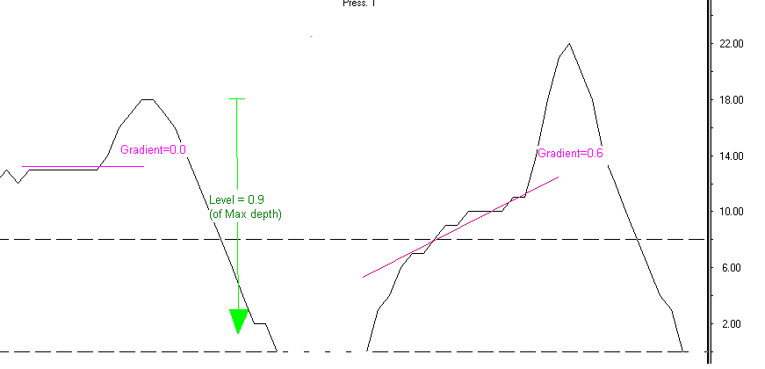

Dive Stops (magenta): If the parameter “Dive Stops Gradient” is set to 0.6 then both dive stops will be recognized by MT. If the “Gradient” parameter is set to 0.3 then only the dive stop of the left event will be recognized, since all dive stops will be recognized whose slope is smaller than “Gradient”.

Dive Level (green). If the parameter “Level” is set to 0.9 then MT assumes end of dive when the y-values of the curves are smaller than the head of the green pointer

Gradient I. If the gradient at a diving down- or up-phase is lower than I then MT detects a DiveStop-Event.The diving ascent phase or diving descent phase is assumed to be interrupted (a dive-stop-event) if the dive gradient is smaller than the value of I.

Length 1 Normally you do not have to change this value. If there is a very small sampl. interval or if the data are scatter strongly, then increase this value. Default: =1.
Internal variable of the dive-stop-finder of MultiTrace. Set this value to 2,3 or 4 in case you obtain bad results from the dive stop finder.

Min Duration Min. length of a stop event (in unit sampl interval). Default: N=4

Box Kind searching bottom phase
You can select one of three options how to detect the bottom phase:

Normal. This is the most recommended procedure. The parameters SlopeBoB B, Relation Bottom-Surface and Threshold bottom are interpreted in the way as described above

Fix. Bottom.
If this button is set to 'Fix. bottom' then the parameters SlopeBoB B, Relation Bottom-Surface R and Threshold bottom H are interpreted in this way: B and R will be ignored. The bottom phase is re-defined as: The entire data section of the current dive which is greater than H * MaxDepth is regarded as the bottom phase, where "MaxDepth" is the max. depth of the current dive event.

As AnDive. This is the method used in the program 'AnDive'. It is a simple gradient oriented procedure. Set B to a positive value of at least 1.5. Good values maybe 3, 4 or 5.

Box Wiggles

Wiggle Amplitude G
Wiggles of an amplitude < G will be ignored.
This value allows the program to determine when a wiggle (zig-zag-diving at the bottom phase, hunting) is considered to have taken place. If the amplitude is less then A meter then the animal is considered to dive not zig-zag-shaped.

Search next event When pressing the W key, MT normally analyzes, exports the characteristics and searches the next dive event. When this checkbox is disabled, MT analyzes and exports the results but doesn’t go to the next dive event. At the autom. analysis this item is not to disable i.e. in this case MT always searches the next event irrespective whether this checkbox is checked or not.

Trekk Baseline If enabled: After having found a dive event by command Q or W, MultiTrace automatically sets the baseline (y=0) at the last point (at y(F5)) of the current dive event.

Adjust Size Fit the window to the current dive event concerning the y-size i.e. show the event optimal zoomed.
When 'Adjust Size' is enabled, MultiTrace displays each found event (by Q or W) maximal enlarged in y-size. If adjust is disabled, MultiTrace always uses the same y-scale: It is more easy for the user to see instantly the different dive shapes. If you enable 'adjust' then it is recommended to install a grid (Menu View/Grid).

No visualisation Only for the autom. analysis. MT does not show every found dive event. In this way the analysis is faster.

Create images If enabled MT creates a JPEG-file of each found dive event and stores it into the subdirectory “\images” of the folder of the input file. If the subdir “images” does not exist then MT creates it. ‘Create images’ effects the manual analysis as well as the autom. analysis.

Box Water Temperature

If Include frequencies ..is enabled then water temperatures of channel 2 (if exist) are included into the dive result file. MT calculates the mean water temp. of the entire dive and at the bottom phase. The min. and max. temp. at the bottom phase. The temperature at max depth and around max depth. Type in at Surround max depth a surrounding S of the time at max depth MaxD. MT calculates the mean temperature on an interval [MaxD-S, MaxD+S].

MNr Bins Select the amount of bins (i.e. the number of additional columns). Max 30 bins.
Min y-value Select th lowest bin
Max y-value Select the highest bin
Box water temperature

Box Frequencies
If include is enabled then histogram data (frewuencies of y-values) are included into the dive result file.

Nr Bins Select the amount of bins (i.e. the number of additional columns). Max 30 bins.
Min y-value Select th lowest bin
Max y-value Select the highest bin

Example to frequencies: Assume the current dive event covers the range 0 to 100 meters. If you select NrBins=10, MinY=50, MaxY=100, then there will be added 10 columns into the dive result file. The first of these columns contains the amount of depths between 50 and 55 meter, the second column the amount of depth values between 55 and 60 meter,… the 10th column the amount of depths between 95 and 100 meter.

The above parameters are stored in the configurational set up. Thy can be changed at any time during the analysis without having to leave the programme or the data set.

How to analyse dive data

1) Adjust the baseline: Use one ot the methods of the menu item 'Baseline' to adjust the baseline.
Example: Set the working cursors F4 and F5 at a section of the water surface and hit the key '^M',
or Set the F4 cursor at one point of the water surface and hit the key '^4'.

2) Set the parameters to find the dive events at the menu item 'Analysis/Parameters'
The most important parameter is 'Threshold T'.

3) Perform an evaluation phase. Set the F4 and the F5 cursor at the begin of the channel (e.g. by the key: F4, home, F5, home) Then press Q to let MT find the first event. Repeat several times 'Q' to continue searching the next event. If necessary change the parameters to find dive events. Press several times 'W' to export the results into a test file. Check the result file: Format and content okay?

4) Perform the analysis. Set the F4 and the F5 cursor at the begin of the channel (e.g. by the key: F4, home, F5, home) resp. before the event to find.

Then press 'W' to let MT find the first event, to analyze it and to store the results. If necessary correct several positions e.g. begin of dive (=F4-cursor) *). If necessary change the parameters to find dive events. Each time MT shows an event, you may change the position of the cursors. If you have changed the bottom phase cursors, press ‘A’ to let MT search again dive stops and wiggles.

Repeat this procedure till end of the channel.

*) At the first hit of the key 'W' MT searches the next event after the F5 cursor. At the 2nd hit of 'W' MT analyzes and exports the results (then searches the next event) so that user modifications at the cursors (bottom phase, dive borders) are valid.

See the help at menu ‘Analysis/Automatic Analysis/Help’ to perform an automatic analysis.

Note: MT expects 'positive' depth values i.e. with increasing depth the y-values increases. In case your dive data are 'negative' e.g. baseline =0.0 and dive value =-20.0 then invert your data before starting the analysis by menu item 'Process/Multiply (-1)'

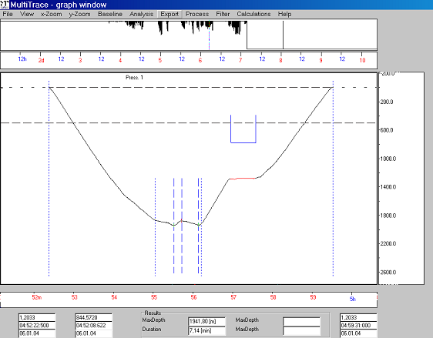
Dive stop
Wiggles
Bottom

The dive result file

The result file is a simple text file. You can load this file into your preferred spreadsheet program. (Hint : If you name the resultfile ….xls then a click to this file calls Excel) Each line of the result file contains the characteristics of one dive event and consist of several columns.

Notation:
Event - The data between the working cursors F4 and F5
F5(t) - The time at the F5-Cursor
[sec] - The unit seconds

The columns of the result file:
# Nr of event.
Onset Onset of the event =F4(t) as dd.mm.yy hh:mm:ss
Duration Duration of the event = F5(t)-F4(T) [sec]
Onset bottom Onset of bottom dive = F8(t)
Julian day Onset of the event as Julian day
Pause Pause between events = F4(t) -F5(trecent)
Pause h:m:s Pause between events [hh:mm:ss]
Dur. desc. Duration of descend diving= F8(t)-F4(t) [sec]
Dur. bott. Duration of bottom diving=F9(t)-F8(t) [sec]
Dur. asct. Duration of ascent diving=F5(t)-F9(t) [sec]
VV Down Vertical velocity at the descent phase [m/sec]
VV Bottom Vertical velocity at the descent phase [m/sec]
VV Up Vertical Velocity at the ascent phase [m/sec]
Max. depth Maximal depth of the event [m]
Min. depth Minimal depth at the bottom phase [m]
Expl: The minimum of the depth values (20, 22, 23, 22, 20) is 20.
Mean depth Mean depth at the bottom phase [m]
Median depth Median depth at the bottom phase [m]
Sum way vert. Total vertical way at the bottom phase [m] = SUM(abs(Delta(depth)))
Example: Assume all recorded depth values at the bottom phase are:
20, 25, 30, 22, 27, 20. Then "Sum way vert." is: 5 + 5 + 8+ 5 + 7 = 30.
SD Standard deviation at the bottom phase [m]

If "wiggle-analysis" exist:
Mean Ampl. Zig Mean of the amplitudes of the wiggles-up [m].
StdDev Zig Standard deviation of the wiggles-up [m].
Median Ampl Zig Median of the amplitudes of the wiggles-up [m/sec].
Mean Ampl. Zag Mean of the amplitudes of the wiggles-down [m].
StdDev Zag Standard deviation of the wiggles-down [m].
Median Ampl Zag Median of the amplitudes of the wiggles-down [m/sec].
Wiggles Onset Date and time of first wiggle.
Wiggles End Date and time of last wiggle.
Duration Entire wiggle interval. Time(last) - Time(first)
Depth at first Depth at the first wiggle.
Depth at last Depth at the last wiggle.
Depth Min of all Minimum depth of all wiggles.
Depth Max of all Maximum depth of all wiggles.

If "dive-stop-analysis" exist:

Onset Onset of a dive stop relative to event onset [sec].
Dur Duration of the dive stop [sec].
Depth Depth of the dive stop [m].
Vertical Velocity The vertical speed of the dive stops is the gradient before the dive stop (depth_1 - depth_2/(time_1 - time_2)), whereas depth_2 and time_2 refers to the onset of the current dive-stop and depth_1 and time_1 refers to the end of the preceding dive-stop. In case it is the first dive-stop at the descending resp. ascending phase then depth_1 and time_1 refers to the begin of the dive event (F4) resp. end of the bottom phase (F9).
:
(4 times for the descent phase and
4 times for the ascent phase.)

Note: Vertical velocities are always: Delta(depth) / Delta(times)
with Delta = difference of values. Example: "VV Bottom Vertical velocity bottom phase" is
[Depth(F9) - Depth(F8)] / Time(F9) - Time(F8) . Hence if depth(F9) < depth(F8) (animal is slowly diving upward at the bottom phase) then the "vert. velo. bottom phase" is neagtive.

Tips on conducting a successful analysis

1. After having set the depth parameters so that the required events can be found the baseline should be set to be zero (if this is not already the case). The easiest way to do this is to move the F4/F5 working cursors to an area known to correspond to the water surface and then press '^M'. By doing this a mean value will be calculated for the area between these two cursors and the baseline will be adjusted. Should the apparent position of the water surface permanently drift (as is the case in small depth loggers) you can either enable the option "K Trekk baseline" (see above "Parameters for the dive analysis") or use one of these commands to adjust manually the baseline:
- Hit the "^4" resp. "^5"-key. The baseline will shift to the value at the F4- resp. F5 cursor
- Press "^U" or "^D". The baseline will shift up- resp. downward.
- Adjust the baseline by the mean between the F4- and F5-cursor (command "^M").
- Then type in the y-value of the new baseline numerically.

2. It can sometimes be useful to show the threshold as a dashed line and menu “View/Subsid. line” does just that. It is also generally desirable to optimise the other two channels - if they are loaded - by temporary activating them (mouse click) then using one of the zoom functions (command ^PgUp-, ^PgDn, Up-, Dn-key.).

3. Set all cursors (F4,F5,F8,F9) at the start point. Normally this occurs at the beginning of the displayed graphs so the commands F6 HOME and F10 HOME are sufficient but the cursors can also be set wherever you consider appropriate. The analysis can now begin. Activate the working graph to be the one containing the depth values (mouse click into channel window) and press 'Q' to find the first dive.

4. After you have pressed 'Q' MultiTrace looks from the point of cursor F5 for a dive and shows this on the screen. The F4 and F5 cursors show the beginning and end of the dive whereas the small cursors F8 and F9 show the beginning and end of the considered bottom phase of the dive. When no bottom phase is considered to have occurred the F8 and F9 cursors lie closely together at the deepest point of the dive.

5. User-instigated changes: The F4, F5, F8 and F9 cursors can be moved by the user in the usual manner (note that by pressing F10 you can move F8 and F9 simultaneously). If you choose to push the F8 and F9 cursors closely together the programme will consider the dive as one without a bottom phase (V-shaped profile). The reverse is also true.
The search for a dive event can be repeated with altered parameters (see above) by moving the cursor to a point before the dive and then pressing 'Q'. This means that the process can be repeated until such time as the user is happy with the way the analysis is being conducted. Pressing 'Q' under normal conditions tells MultiTrace to move onto the next diving event and to ignore the present event without writing corresponding data into the output file.

6. By pressing 'A' you will set in motion analysis of the depth data. The duration of the event and the max. depth of the event will be displayed at the screen. However, actually this command is not necessary for the analysis, instead you should use the command "W".
Useful is this command for: If you had altered the F4 or F5-cursor (thus the begin or end of dive) or the bottom borders or the baseline, then a hit at "A" searches again the wiggles and the dive stops and changes the displayed values "Duration" and "Max depth".

7. 'W' analyses the event, writes the results of the analysis in the output file on the hard disk, but actually does more than this: The next event is automatically searched for and analysed. Thus, if sequential events in a dive curve are to be analysed it is enough to simply repeatedly press the 'W' key (rather than Q, A and W). If, in this process, a result is not considered satisfactory, the situation can be rectified by moving the F5 cursor back and changing the parameters. If the wiggle amplitude is to be changed the A-key has to be pressed again to allow calculation of the extremes once more. Changes in the parameters will only become apparent when the programme searches for the next event. In order to work the displayed event using the changed parameters it is necessary to move the F8 and F9 cursors (press F10) to a point before the present event and then press 'Q'.

8. If the temperature graph shows a feeding event to which the user would like to assign a particular dive which has just been analysed, then the user must move to the temperature graph and then find the beginning and end of the temperature event by typing in 'Q'. This is analysed via 'A' and can be written in the dive output file by pressing 'W'.

9. In the same way a comment can be entered although this comment need not be typed in last; the information can be entered at any time.

Before starting the analysis and exporting the results (Command W) hit several times the key Q to check whether all parameters are set properly. Then set F4 and F5 back to the starting position. In any case do this, if you want to perform an automatic analysis.

If all settings are good (events will be detected properly) then firstly hit only W a few times. Leave MT and check whether the format of the output file (date format, value separator, decimal point) is as expected. (Change these format settings by the command FT)

The wiggle analysis

The dive curve (depth data) of many sea-animals has this shape: Diving down (the "descent phase"), sometimes staying a long time under water at nearly the same depth (the "bottom phase"), then diving up (the "ascent phase"). Some animals are hunting at the bottom phase. The hunting is visible by up and downs at the bottom phase with relatively small amplitudes and durations. The wiggle-analyse analyses these ups and downs. It counts the number of wiggles, it analyses the amplitudes (mean, mode, max) and the gradient (mean and max) of the wiggles. A wiggle analysis is mainly interesting for the dive analysis of animals which have a evident and large hunting phase at the bottom phase, e.g. sea mammals.

If you have a MultiTrace (dive) including a wiggle-analysis then there is the parameter "Wiggle Amplitude" (in the menu Analysis/Parameters). Type in at this item the minimal required amplitude for the wiggles. In other words: wiggles of a lower amplitude will be ignored by MultiTrace.

Example:
If the user had choosed a value of 2 for the wiggle amplitude, then only wiggles with an amplitude greater than 2 will be identified. In this example the extrema Q0, Q2, and Q4 will be identified, but not Q1 and Q3. Q2 will be identified as 'Wiggle-up' and Q4 as 'Wiggle-down, the amplitude of a wiggle Qn is D(Qn) - D(Qn-1) with D(Q)= Depth at Q. Thus Q2 has a negative amplitude and Q4 has a positive amplitude.

depth
Q2 (Wiggle-up) ^
* |- 20 m
* * * |
* * Q3 * |- 22 m
Q1 * * * * |
* * * * * * ---------} |- 24 m
* * * * * }-- 2 meter |
* * * --------- } |- 26 m
* * * |
* * |- 28 m
Q0 Q4 (Wiggle-down) |

During the analysis:
When pressing "Q" or "W" in order to find the next event , MultiTrace searches as usual the onset and the end of the dive event (indicated by F4 F5-cursor) and the onset and the end of the bottom phase (F8, F9). If a bottom phase exist, then MultiTrace scans the bottom phase for wigglings. Each found extrema MultiTrace indicates in the curve by a small vertical line. The user cannot move these lines. The only way to intervene is to change the parameter "wiggle amplitude" and to start once more the wiggle detecting by pressing the A-key.

The dive-stop-analysis

Some animals interrupts the ascent or descent phase, stay or swim for a while at the same depth level before they continue the descent or ascent phase. The dive-stop-analysis analyses these interrupts. It measures the onset of the stop, the end, the depth and the vertical velocity before the dive-stop. In addition there can be counted a number of somewhat events during the time of divestop acquired with another sensor.
MultiTrace can search and analyse up to four divestops at the descent and at the ascent phase, thus totally: eight divestops.

If a dive stop analysis exist then there are three additional items at the dialog Analysis/Parameters:
"Stop gradient", "Length1", "Length2"
Type in at "Gradient" the desired gradient the dive stop must have at least. If you choose gradient=0.0 then only dive stops will be recognised with no movement downward.
I.e. the animal really stops totally the descent phase or even dives a bit upward at this phase.
If you choose a gradient of -0.1 then a dive stop will be recognized, even if the animal continue increasing depth (at the descent phase) with maximal 0.1 meter per second.
The parameters E and N affects the amount of data points to use for the calculation of the gradient. Generally these parameters are set to 4 and 1. Modify these values only if you are not content with the detecting of dive stop events.

During the analysis: After pressing "Q" or "W" detected dive-stop-events are indicated in the graph by a horizontal bracket : I________I You may modify these dive stops by use of the mouse (recommendation: zoom in before.).
- Enlarge or reduce the duration of a dive-stop event by pointing to one of the ends of these small lines and change it by drag-and-release in horizontal direction.
- Delete or melt dive-stops by the dialog “Analysis/Dive Stops”.

The automatic analysis

Set the dive finding parameters by menu “Analysis/Parameters” as described above, set the cursors F4 and F5 around the section you want to analyse (by "F4 Home F5 End" the entire file) and choose menu item “Analysis/Auto Analysis”. MultiTrace then will analyze the selected file section without stopping after each event. If you set the window size large (F2 right of F4 and F1 left of F4) then the speed of the analyses will increase.

Short information for the dive analysis

0) Enter the name of the data, its range, time ... in the main dialog or load the configurational set up file.
1) Adjust the baseline: F4, F5 on the water's surface, mean (^M).
2) Set the search parameters using
3) Choose start point (F5), set the programme to look for the first event (Q).
4) Similarly, correct search conditions (cursor, parameters).
5) Analysis, output, search for next event (W) continue with step 4 or step 5. The key ^F3 is particularly helpful, showing the working area optimally zoomed.

How to analyse dive bouts

Since the bout finder of MT uses the dive finder, do the steps 1) to 3) of the chapter “How to analyze dive data”. (Adjust baseline, Set parameters, Perform evaluation phase) In addition set the parameters ‘Bout Intermediate time’ and ‘Bout min. duration’. When the dive parameters are set properly - i.e. at the evaluation phase (key Q) MT finds the dives correctly - then set the F5 cursor before the first bout to search and press ^B. which forces MT to search the first bout. Now you may correct the position of the F4 and F5 cursor which indicates the onset and the end of the sound bout.

Press again ^B to analyze the current bout, to store the results in the ‘Result file bouts’ and to search the next bout. Repeat this procedure until the end of the channel is reached. (Don’t forget to press ^B also after the last found bout, else it will not analyzed.)
In case the baseline varies, adjust the baseline by the commands ^U and ^D (baseline trekking).

Once a bout is found you may also perform specific operations on the data of the bout. For instance you can create a histogram and export it into a text file (menu Calculations/Histogram) or export all dives of a bout as a text file (menu Export/Text).

The bout result file is a simple text file. You can load this file into your preferred spreadsheet program. Each line of the result file contains the characteristics of one bout and consist of several columns.

The columns of the bout result file:
Count Serial number of current bout
BoutOnset Date and time
Nr Dives Amount of dives of current bout
Nr V-Dives Amount of V shaped dives
Nr U-Dives Amount of U shaped dives (with bottom phase)
FrqDives Dive frequency. NrDives/DurationBout [1/h]
DurationBout Duration of bout [sec]
TimeSpentBottom Total bottom time [sec]
TSB/Dur. Bout (Total bottom time) / (Duration of bout)
MaxDuration Longest dive [sec]
AvgDuration Average duration of all dives [sec]
MaxDepth Greatest depth al all dive events [m]
AvgMaxDepth Average of max. depths of all dive events [m]
MeanDepth Average depths of all dives (without surface) [m]
MeanBottom Average depths of all bottom phases [m]
TotDiveTime Total time spent diving [sec]
Integral Integral of all dive events [m*h]
Int./Dur. Bout Integral / DurationBout [m]
Diving Efficiency Total bott. time * Surf. time /Total dive time [sec]
Avg Depth V-Dives Average depth of all V-shaped dives [m]
Max Depth V-Dives Max depth of all V-shaped dives [m]
Avg Depth U-Dives Average depth of all U-shaped dives [m]
Max Depth U-Dives Max depth of all U-shaped dives [m]
MeanROD (all points) Average of all ‘Rate of Descents’ *) [m/sec]
Average RODs Average of all grad. of all descent phases *) [m/sec]
MeanROA (all points) Average of all ‘Rate of Ascents’ *) [m/sec]
Average ROAs Average of all gradients of all ascent phases *) [m/sec]
Nr Wiggles Amount of wiggles of all dives
Nr DiveStops Amount of DiveStops of all dives

*) The difference of MeanROD and AverageRODs: The AverageEODs is the average of the RODs (rate of descent=vertical velocity) of all descent phases, the MEanROD is the average of the gradients of all data of the descent phase.
Example: Assume a bout contain two dives, one great dive event Dg and one small dive event Ds. Dg has a large descent phase with a gradient of 1 m/sec and a descent duration of 10 sec. Ds has a small descent phase of 1 sec and gradient 0.1 m/sec.
The Average RODs is (1 m/s+ 0.1 m/s) / 2. = 0.55 m/s
The MeanROD is (1 m/s * 10 + 0.1m/s) / 11 = 0.918 m/s

Appendix A . Important commands

F1,F2,F3 Activate left-, right-, both window borders.
F4,F5,F6 Activate left-, right-, both working cursors.
F8,F9,F10 Activate left-, right-, both 2nd work. cursors (Bottom Cursor).
Shift-F3 Activate window borders and cursor (for moving by ->, ->.
^F3 Jump window around cursor and automatic zoom.
^Sh-F6 Jump working cursor (F4,F5) into window (F1,F2).
^F10 Jump 2nd working cursor (F8,F9) into window (F1,F2).
->,<- Move activated element (border or cursor).
^<-, If F3 pressed before then move window about one window size.
^-> If F6 pressed before then move window about one working area.
Home Move activated element(s) to the begin of graph.
End Move activated element(s) to the end of graph.
PgUp, PgDn Increment, decrement speed of activated element
^PgUp,^PgDn Zoom in/out vertical
Up, Dn arrow Shift image of up or down.

W Ana. results Analyse current event, export results and - if ^SS is enabled - search next event.
A Analyse Prompt current max. depth and event duration at screen.
Q Search Search next event.
C Comment Write a user comment into a output (result) file.

^U Baseline trekking
^D Baseline trekking
^M Mean Calculate the arith. mean of working area and adjust baseline.
^4 Adj, baseline y=0 at the F4-cursor.
^5 Adj. baseline y=0 at the F5-cursor.

(^ : Ctrl-key)

